Project Report
On
An End-to-End Data Mining Framework Using Supervised, Unsupervised, and Ensemble Learning Approaches

Prepared For
Mahbub Hasan, Lecturer
CSE353.3 - Introduction to Data Mining

Prepared By
Group Name: Cloud
Asaduzzaman | 2022000000164

Date: 21/10//2025



Southeast University
Department of Computer Science and Engineering

Executive Summary 3
1. Introduction 3
1.1 Problem Context 3
1.2 Problem Statement 3
1.3 Research Gaps 4
1.4 Project Objectives and Contribution 4
2. Background of the Study 5
2.1 CMS Open Payments Program 5
2.2 Theoretical Framework 5
3. Methodology: Data Preparation and ETL Pipeline (Project #1) 5
3.1 Dataset Selection and Verification 5
3.2 ETL Process Overview 11
3.3 Data Sources and Connections 11
3.4 Dimension Processing Details 12
3.5 Fact Table Processing 13
3.6 ETL Reliability 14
3.7 Logical Modeling and Designing: 15
Why the Star Schema Was Chosen 15

Executive Summary
The CMS Open Payments dataset (15.4M records) presents a complexity challenge that limits actionable insights for auditing financial conflicts of interest (COI) in healthcare. This project developed a two-phase data science framework to enable predictive classification and recipient segmentation.

Phase I: Data engineering, cleaning, and feature generation via Pentaho ETL, including date parsing, categorical encoding, and transformation of skewed features.

Phase II: Machine Learning modeling using a 3:2 ratio of supervised to unsupervised approaches:

- Supervised models: LightGBM, Random Forest, XGBoost classifiers for multi-class payment prediction. XGBoost achieved 95.83% test accuracy and a weighted F1-score of 0.95, identifying high-risk payment types with high confidence.
- Unsupervised models: K-Means and Gaussian Mixture Model (GMM) clustered healthcare providers into meaningful behavioral groups. Isolation Forest and DBSCAN were applied for anomaly detection and further validation of segment boundaries.
The framework provides regulatory auditors with a scalable tool to classify transactions and detect high-risk recipient groups for COI auditing.

1. Introduction

1.1 Problem Context
The CMS Open Payments program mandates transparency in financial ties between manufacturers and healthcare providers to mitigate conflicts of interest. Manual auditing is infeasible due to:

- Over 15.4 million records
- High-cardinality categorical features
- Extreme skew in payment amounts
This requires automated predictive and segmentation methods for efficient risk assessment. As said before it contains all general (non-research, non-ownership related) payments from the 2024 program year [January 1 – December 31, 2024]

1.2 Problem Statement
The project addresses two primary problems. First, the challenge of transforming raw, complex Open Payments data into a clean, machine-learning-ready format. Second, the need to accurately classify payment types and uncover meaningful recipient segments to support conflict-of-interest auditing.

1.3 Research Gaps
- To verify, clean, and transform the Open Payments dataset and generate relevant features.
- To predict the nature of payments using supervised machine learning models.
- To segment healthcare providers into meaningful groups using unsupervised clustering techniques.

1.4 Project Objectives and Contribution
Objective | Phase | Purpose
O1: Data Preparation | Project #1 | ETL, EDA, feature engineering
O2: Classification | Project #2 (Supervised) | Predict payment nature using three classifiers
O3: Segmentation | Project #2 (Unsupervised) | Cluster HCPs using PCA-reduced features and K-Means

Contribution: A validated predictive auditing framework combining classification, clustering, and anomaly detection to support COI risk assessment. And individual contributions are as follows.

Name | ID | Contribution
Asaduzzaman | 2022000000164 | Supervised Models (LightGBM, Random Forest, XGBoost, CatBoost, Logistic Regression)
Asaduzzaman | 2022000000164 | Unsupervised Models (K-Means, GMM, DBSCAN, Isolation Forest)

2. Background of the Study

2.1 CMS Open Payments Program
- Requires reporting of selected features to HCPs.
- Dataset includes payment value, form, nature, product details, and recipient specialty group.
- Complexity arises from variety in payment types, high-cardinality categorical features, and geographic/temporal distribution

2.2 Theoretical Framework
- Supervised Learning (Classification): Multi-class prediction of payment type for detection.
- Unsupervised Learning (Clustering/Dimensionality Reduction): Discover hidden patterns and segment HCPs.

3. Methodology: Data Preparation and ETL Pipeline (Project #1)

3.1 Dataset Selection and Verification
The CMS Open Payments dataset (OP_DTL_GNRL_PGYR2024_P06302025_06162025.csv) contains,

- 15,397,627 Rows (15.3M)
- 91 Columns (Features)

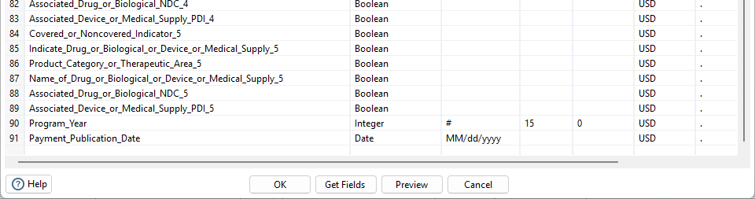

The dataset includes highly granular fields such as recipient demographics, payment details, product information, and dates. Verification confirmed data integrity, completeness, and compliance with schema requirements for downstream ML tasks.

Here is a complete dictionary of the raw real world dataset:
Field Name | Description | Type | Constraints
Change_Type | Indicator showing if the payment record is New, Added, Changed, or Unchanged compared to previous publication. | string | Enum: NEW, ADD, CHANGED, UNCHANGED
Covered_Recipient_Type | Indicates if recipient is physician-covered, non-physician practitioner, or teaching hospital. | string | maxLength: 50
Teaching_Hospital_CCN | CMS Certification Number of the teaching hospital. | string | maxLength: 6
Teaching_Hospital_ID | System-generated unique identifier of teaching hospital. | string | maxLength: 38, pattern: digits only
Teaching_Hospital_Name | Name of the teaching hospital. | string | maxLength: 100
Covered_Recipient_Profile_ID | Unique ID for covered recipient profile. | string | maxLength: 38, pattern: digits only
Covered_Recipient_NPI | National Provider Identifier of covered recipient. | integer | max: 9999999999
Covered_Recipient_First_Name | First name of the recipient. | string | maxLength: 50
Covered_Recipient_Middle_Name | Middle name of the recipient. | string | maxLength: 35
Covered_Recipient_Last_Name | Last name of the recipient. | string | maxLength: 35
Covered_Recipient_Name_Suffix | Name suffix of the recipient. | string | maxLength: 15
Recipient_Primary_Business_Street_Address_Line1 | First line of primary practice/business address. | string | maxLength: 100
Recipient_Primary_Business_Street_Address_Line2 | Second line of primary practice/business address. | string | maxLength: 75
Recipient_City | City of primary practice/business. | string | maxLength: 40
Recipient_State | State/territory abbreviation of primary practice/business. | string | maxLength: 2
Recipient_Zip_Code | 9-digit ZIP code (or ZIP+4). | string | maxLength: 10, pattern: \d{5}(-\d{4})?
Recipient_Country | Country of primary practice/business. | string | maxLength: 100
Recipient_Province | Province of practice if outside US. | string | maxLength: 35
Recipient_Postal_Code | Postal code if outside US. | string | maxLength: 20
Covered_Recipient_Primary_Type_1-6 | Primary type of medicine practiced by recipient (PY2021+ supports 6 fields). | string | maxLength: 100
Covered_Recipient_Specialty_1-6 | Specialty based on standardized provider taxonomy (PY2021+ supports 6 fields). | string | maxLength: 300
Covered_Recipient_License_State_code1-5 | 2-letter state license abbreviation. | string | maxLength: 2
Submitting_Applicable_Manufacturer_or_Applicable_GPO_Name | Name of submitting manufacturer or GPO. | string | maxLength: 100
Applicable_Manufacturer_or_Applicable_GPO_Making_Payment_ID | Unique ID of manufacturer/GPO making payment. | string | maxLength: 38, pattern: digits only
Applicable_Manufacturer_or_Applicable_GPO_Making_Payment_Name | Name of manufacturer/GPO making payment. | string | maxLength: 100
Applicable_Manufacturer_or_Applicable_GPO_Making_Payment_State | State of manufacturer/GPO. | string | maxLength: 2
Applicable_Manufacturer_or_Applicable_GPO_Making_Payment_Country | Country of manufacturer/GPO. | string | maxLength: 100
Total_Amount_of_Payment_USDollars | Payment amount in USD. | number | max: 999999999999.99
Date_of_Payment | Date payment was issued (or first in series). | date | format: %m/%d/%Y
Number_of_Payments_Included_in_Total_Amount | Count of discrete payments in total. | integer | max: 999
Form_of_Payment_or_Transfer_of_Value | Payment method. | string | maxLength: 100
Nature_of_Payment_or_Transfer_of_Value | Nature of payment. | string | maxLength: 200
City_of_Travel | Destination city for travel payments. | string | maxLength: 40
State_of_Travel | Destination state for travel payments. | string | maxLength: 2
Country_of_Travel | Destination country for travel payments. | string | maxLength: 100
Physician_Ownership_Indicator | Indicates physician ownership in manufacturer. | string | maxLength: 3
Third_Party_Payment_Recipient_Indicator | Indicates if payment went to third party. | string | maxLength: 50
Name_of_Third_Party_Entity_Receiving_Payment_or_Transfer_of_Value | Name of entity receiving payment. | string | maxLength: 100
Charity_Indicator | Indicates if third party is a charity. | string | maxLength: 3
Third_Party_Equals_Covered_Recipient_Indicator | Shows if third party is covered recipient. | string | maxLength: 3
Contextual_Information | Free-text info about payment. | string | maxLength: 500
Delay_in_Publication_Indicator | Indicates if payment publication delay requested. | string | maxLength: 3
Record_ID | System-assigned transaction ID. | string | maxLength: 38, pattern: digits only
Dispute_Status_for_Publication | Indicates if payment is disputed. | string | maxLength: 3
Related_Product_Indicator | Indicates if payment is related to products. | string | maxLength: 100
Covered_or_Noncovered_Indicator_1-5 | Indicates if product is covered or non-covered (up to 5). | string | maxLength: 100
Indicate_Drug_or_Biological_or_Device_or_Medical_Supply_1-5 | Indicates type of product (drug/device/biological/medical supply). | string | maxLength: 100
Product_Category_or_Therapeutic_Area_1-5 | Product category or therapeutic area. | string | maxLength: 100
Name_of_Drug_or_Biological_or_Device_or_Medical_Supply_1-5 | Marketed name of product. | string | maxLength: 500
Associated_Drug_or_Biological_NDC_1-5 | National Drug Code of product. | string | maxLength: 13
Associated_Device_or_Medical_Supply_PDI_1-5 | Primary Device Identifier of product. | string | maxLength: 100
Program_Year | Year payment occurred. | integer | max: 9999
Payment_Publication_Date | Date payment is scheduled to be published. | date | format: %m/%d/%Y

Table: Raw Dataset Dictionary

3.2 ETL Process Overview
The ETL process was implemented in Pentaho Data Integration (PDI) to clean, transform, and load the data into a PostgreSQL data warehouse. The workflow followed a dimensional modeling (Star Schema) pattern, consisting of three primary transformations orchestrated in the jobProcess.kjb:

Step | Transformation Name | Purpose / Description
1 | cleaningProcess | Cleans data: null handling, string standardization, date extraction
2 | dimProcess | Populates dimension tables: identity, profession, address, product, manufacturer, date, flag, payment detail
3 | factProcess | Generates surrogate keys, joins dimensions, loads central fact table fact_payment
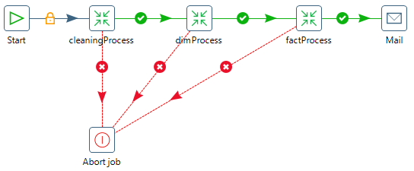
Figure: ETL Job Flow
This structured approach ensures data quality and establishes a foundation for accurate and efficient reporting.

3.3 Data Sources and Connections
The ETL process sources its data from a cleaned dataset and stores the results in a PostgreSQL warehouse. Key attributes and connections are described in the table below:

Attribute | Details
Source File | cleanedDataset.txt
Field Types | Strings (text), BigNumber (payments), Integer (IDs/counts), Date (payment dates)
Target Database | PostgreSQL data_warehouse on localhost
Connections | updatedConnection (dimProcess), factConnection (factProcess)
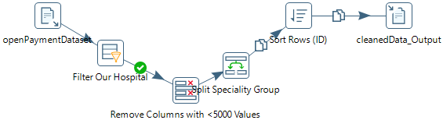
Figure: ETL - Cleaning Flow

By clearly defining source types and database connections, the ETL process maintains data integrity and ensures that each transformation stage accesses the correct dataset.

3.4 Dimension Processing Details
Each dimension undergoes a series of processing steps to prepare data for analytics. These steps focus on cleansing, standardization, and structural consistency:

Processing Task | Description
Cleansing & Standardization | Replace <NULL> with UNKNOWN or NA, remove special characters, standardize categorical values, uppercase text, trim spaces
Address Concatenation | Combine street address lines into a single field per recipient
Date Extraction | Create 6 new fields from Date_of_Payment and Payment_Publication_Date (year, month name, day name)
Dimension Loading | Populate 8 dimension tables optimized for surrogate key generation and downstream joins

Table: Feature Processing and Changes

These steps ensure that the dimension tables are clean, standardized, and ready to support analytical queries and reporting workflows.
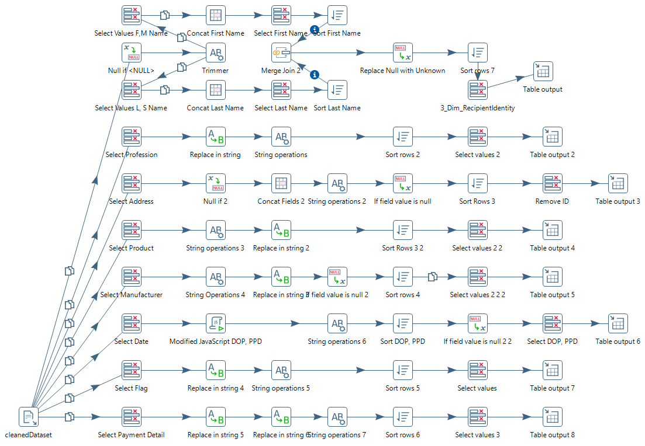
Figure: Dimension Processing Transformation Flow

3.5 Fact Table Processing
The fact table is assembled by combining measures with dimension surrogate keys to form a central analytics table.

Processing Step | Description
SurrogateKey Retrieval | Extracted surrogate keys from all related dimension tables to uniquely identify dimension records.
Fact Assembly | Selected key measures (Total_Amount_of_Payment_USDollars and Number_of_Payments_Included_in_Total_Amount), generated payment_id, sorted data streams, and performed a multiway merge join to consolidate all relevant information.
Fact Loading | Loaded the consolidated fact_payment table in the data warehouse, including all dimension surrogate keys and measure fields for reporting and analysis.

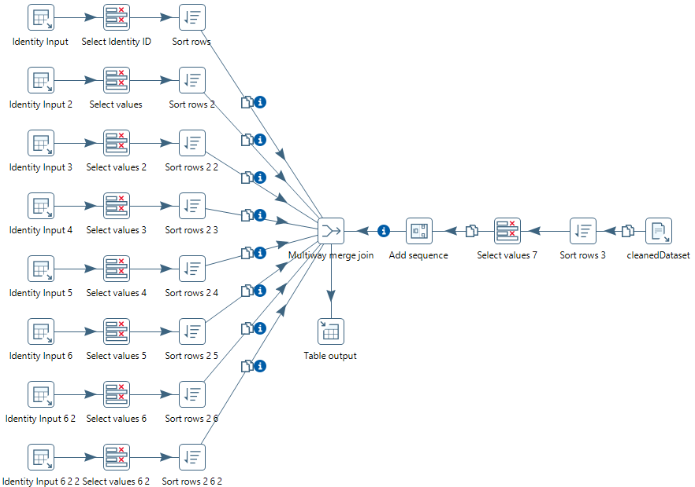

3.6 ETL Reliability
The ETL workflow is designed to ensure data consistency and error-free execution.

Reliability Aspect | Description
Sequential Execution | Each transformation runs only after the successful completion of the previous step, ensuring orderly processing.
Error Handling | The ETL job is configured to abort immediately upon any transformation failure, preventing incorrect or incomplete data from being loaded.
Notifications | Sends an email notification to mahbub.hasan@seu.edu.bd upon successful job completion, confirming that the ETL process has finished without errors.

3.7 Logical Modeling and Designing:
This is the ERD of clean data that was stored in the PostgreSQL database.
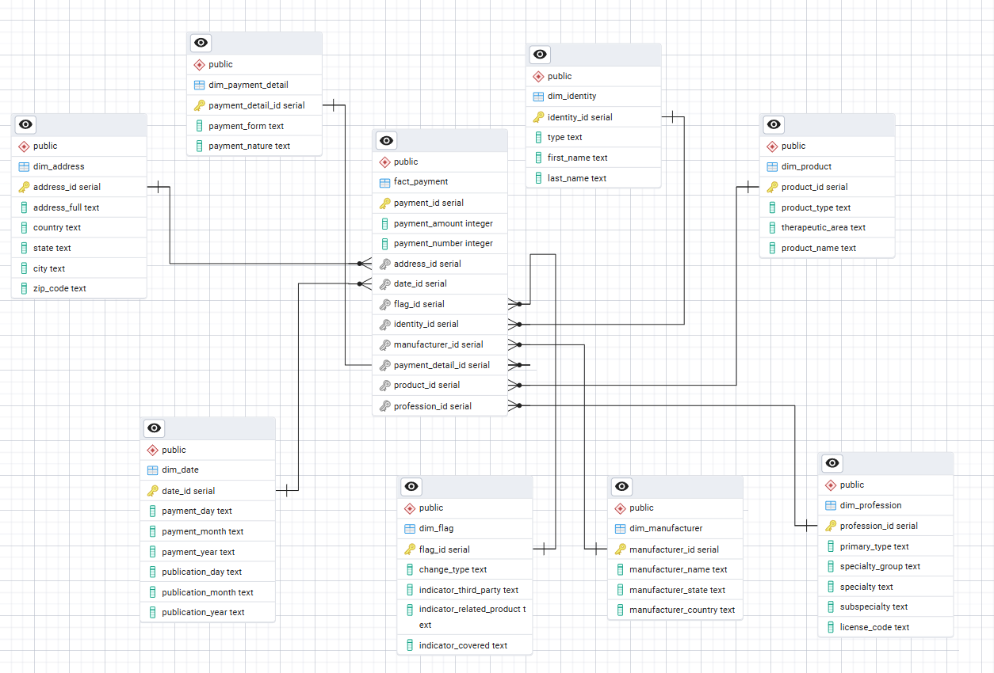

The above given relation was made because -

Why the Star Schema Was Chosen
- Central Fact Table:
The design centers on the fact_payment table, which records measurable events such as payment amounts and counts that are ideal for aggregation and reporting.
- Descriptive Dimensions:
Contextual data (who, what, when, where, how) is stored in separate dimension tables, allowing flexible and readable analysis without redundancy.
- Analytical Efficiency:
The schema reduces join complexity and improves query performance using surrogate keys and denormalized dimensions.
Updated Feature Dictionary:
Updated Column Name | Description | Type / Notes
change_type | Indicator showing if the record is new or added | Enum: NEW, ADD
indicator_third_party | Indicates if payment was made to a third party | Enum: ENTITY, INDIVIDUAL, NO THIRD PARTY PAYMENT
indicator_related_product | Indicates if the payment was related to a specific product | Enum: YES, NO
indicator_covered | Indicates if the related product is “covered” under Open Payments rules | Enum: UNKNOWN, NON-COVERED, COVERED
identity_type | Professional designation of the payment recipient | Enum: NON-PHYSICIAN PRACTITIONER, PHYSICIAN
manufacturer_name | Name of the company that made the payment | string
manufacturer_state | State where the paying company is located | string
manufacturer_country | Country where the paying company is located | string
payment_form | Method or form of the payment | e.g., CASH, STOCK, ITEMS OR SERVICES
payment_nature | Reason for the payment | e.g., GIFT, TRAVEL AND LODGING, CONSULTING FEE
product_type | Category of the product associated with the payment | e.g., DRUG, DEVICE, BIOLOGICAL
therapeutic_area | Product category or therapeutic area for the associated product | string
product_name | Marketed name of the product associated with the payment | string
Visualization:
From the cleaned data we can see some statistics and variables to be able to make different decisions as which algorithms and models to use. And how this dataset looks like now.